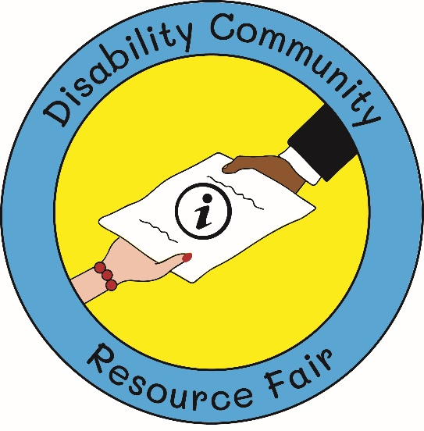

Mechanicsburg Middle School to host Disability Community Resource Fair & Family Fun Day event. All are invited to support and attend!
On Saturday, March 22, 2025, a dedicated group of volunteers will host a Disability Community Resource Fair and Family Fun Day event at the Mechanicsburg Middle School in Mechanicsburg, PA from 10:00 am to 1:00 pm. The event will include family-friendly activities and a community resource fair featuring local service providers. The goal of the event is to help families discover and connect to local services in the area.
We are asking local businesses to support the event through a monetary sponsorship or in-kind donations. In return, we will highlight your business on our Disability Community Resource Fair Facebook page, include your business on promotional materials and media advisories, and your business will be posted on a display at the event that highlights your support.

Attached please find sponsorship opportunities.

Best regards,

Gloria Vollert & Bonnie Mehls
Co-Chairpersons
Disability Community Resource Fair Committee
DisabilityFair@gmail.com

Disability Community Resource Fair
& Family Fun Day
SPONSORSHIP LEVELS
(Must be received by February 7th, 2025)

- Gold ($500)
  - Top-level placement on event t-shirt***
Saturday, March 22, 2025
10:00am – 1:00pm
Mechanicsburg Middle School
1750 S. Market Street
Mechanicsburg, PA 17055
  - Individual sign at event
  - Promotion in event program booklet
  - Promotion on event Facebook page
  - Inclusion in event media advisory
  - Table at event

- Silver ($250)
  - Recognition on event t-shirt***
  - Sign at event with all Silver sponsors listed
  - Promotion in event program booklet
  - Promotion on event Facebook page
  - Inclusion in event media advisory
  - Table at event

- Bronze ($125)
  - Recognition on event t-shirt***
  - Promotion in event program booklet
  - Promotion on event Facebook page
  - Inclusion in event media advisory
  - Table at event

***Email logo (SVG or PNG format) to Gloria Vollert at DisabilityFair@gmail.com***

Name: ___________________________________________________________
Organization: _____________________________________________________
Phone: ________________________ Email: ___________________________
Sponsorship Level: _________________________________________________

FOR PAYMENT INFORMATION PLEASE CONTACT US AT DISABILITYFAIR@GMAIL.COM

